**EX:NO : 13**

**DATE : 24/11/20**

**Aim:**

To write the python program to manage the items sold in an apparel shop using given constraints.

**Program:**

class Apparel:

counter=100

def __init__(self,price,item_type):

Apparel.counter+=1

self.__item_id=item_type[0]+str(Apparel.counter)

self.__price=price

self.__item_type=item_type

def calculate_price(self):

self.__price+=self.__price*0.05

def get_item_id(self):

return self.__item_id

def get_price(self):

return self.__price

def get_item_type(self):

return self.__item_type

def set_price(self,price):

self.__price=price

return self.__price

class Cotton(Apparel):

def __init__(self,price,discount):

super().__init__(price,'Cotton')

self.__discount=discount

def calculate_price(self):

super().calculate_price()

price=self.get_price()

price-=price*(self.__discount/100)

price+=price*0.05

self.set_price(price)

return price

def get_discount(self):

return self.__discount

class Silk(Apparel):

def __init__(self,price):

super().__init__(price,'Silk')

self.__points=None

def calculate_price(self):

super().calculate_price()

if(self.get_price()>10000):

self.__points=10

else:

self.__points=3

return self.set_price(self.get_price()+(self.get_price()*0.1))

def get_points(self):

return self.__points

silk=int(input())

cotton=int(input())

discount=int(input())

a=Silk(silk)

print(a.calculate_price())

b=Cotton(cotton,discount)

print(b.calculate_price())

**LINK:**

[**http://103.53.53.18/mod/vpl/forms/submissionview.php?id=328&userid=1669**](http://103.53.53.18/mod/vpl/forms/submissionview.php?id=328&userid=1669)

**Output:**

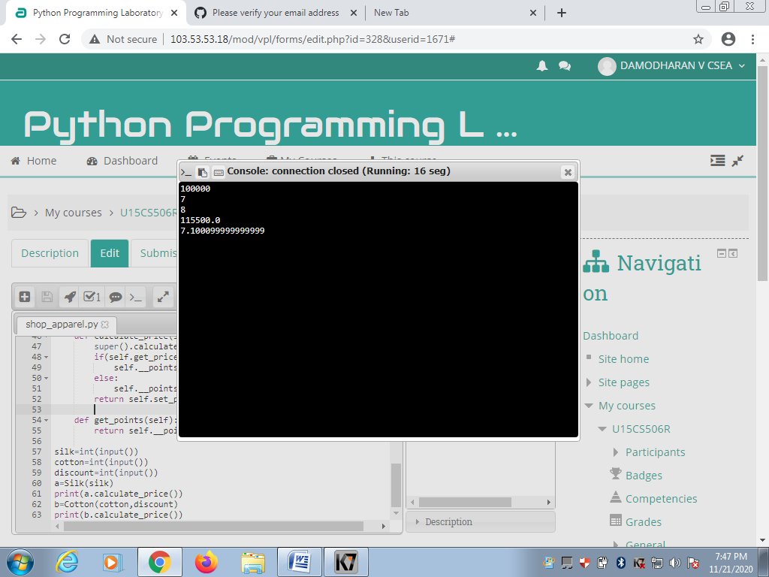

**Result:**

Thus the program to manage the items sold in an apparel shop using given constraints is executed and the output is obtained.